Title of Milestone Document

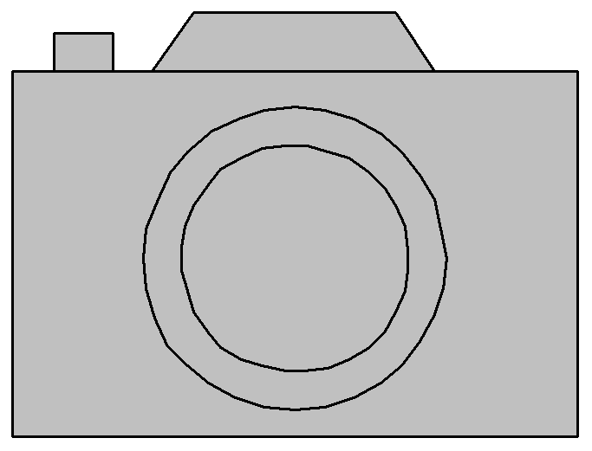

Figure 1: Attractive cover image reflecting subject covered in Milestone Document

Comments on Figure 1. The front page should carry an attractive photo or image, reflecting the work covered by the Deliverable, accompanied by a caption: one or two sentences which explain what the photo / image shows, along with a link to where that subject is covered in more depth in the Deliverable.

|  |  |  |  |
| --- | --- | --- | --- |
| Project Number: | 785907 | Project Title: | Human Brain Project SGA2 |

|  |  |
| --- | --- |
| Document Title: | (Milestone name, as per SGA2 Grant Agreement) |
| Document Filename: | HBP SGA2 Milestone Document.docx (1) |
| Milestone Number: | SGA2 MS0.0.0 (MS0) (please specify HBP & both EC/SyGMa Milestone Numbers) |
| Deliverable Type: | Report |
| Work Package(s): | (specify WPs contributing to this document) |
| Dissemination Level: | PU = Public or CO = Confidential (2) |
| Planned Delivery Date: | SGA2 M? / DD MMM YYYY |
| Actual Delivery Date: | SGA2 M? / DD MMM YYYY |

|  |  |
| --- | --- |
| Authors: | firstname FAMILYNAME, SHORT PARTNER NAME (P#) |
| Compiling Editors: | firstname FAMILYNAME, SHORT PARTNER NAME (P#) |
| Contributors: | firstname FAMILYNAME, SHORT PARTNER NAME (P#), contribution  firstname FAMILYNAME, SHORT PARTNER NAME (P#), contribution  firstname FAMILYNAME, SHORT PARTNER NAME (P#), contribution |
| SciTechCoord Review: | firstname FAMILYNAME, SHORT PARTNER NAME (P#) |
| Editorial Review: | firstname FAMILYNAME, SHORT PARTNER NAME (P#) |

|  |  |
| --- | --- |
| Abstract: |  |
| Keywords: |  |

(1) The Document Filename is a field, which will reproduce the file name automatically. The file name is also included as a field in the document footer. When you create a new version of this document, remember to right click on the filename field and select “update field”!

(2) Unlike Deliverables, Milestone documents don’t have a dissemination level defined in the SGA2 Grant Agreement. PU = Public means a document could be published (e.g. on the HBP public website), once it has been accepted by the Reviewers. CO = Confidential means it should only be shared with the EC, Reviewers and PCO. PU is the default option.

**Table of Contents**

1. Heading – Level 1 4

1.1 Heading – Level 2 4

**Table of Tables**

Table 1: Caption for Table 1. 4

**Table of Figures**

Figure 1: Attractive cover image reflecting subject covered in Milestone Document 1

Figure 2: Caption for Figure 2. 5

Title of Milestone Document

# Heading – Level 1

## Heading – Level 2

### Heading – Level 3

#### Heading - Level 4

##### Heading - Level 5

Body text.

* List with Bullets – 1st level <List Bullets>
  + List with Bullets – 2nd level <List Bullets>
* List with Numbers – 1st level <List Numbers>
  + List with Numbers – 2nd level <List Numbers>

Automatically updated reference to Table 1 below. Note that the caption for a table is ABOVE the table (which may cover multiple pages).

Table 1: Caption for Table 1.

|  |  |  |  |
| --- | --- | --- | --- |
| Table Heading | Table Heading | Table Heading |  |
| Table Body Text | Table Body Text | Table Body Text |  |
| Table Body Text | Table Body Text | Table Body Text |  |
| Table Body Text | Table Body Text | Table Body Text |  |
| Table Body Text | Table Body Text | Table Body Text |  |
| Table Body Text | Table Body Text | Table Body Text |  |
| Table Body Text | Table Body Text | Table Body Text |  |
| Table Body Text | Table Body Text | Table Body Text |  |
| Table Body Text | Table Body Text | Table Body Text |  |
| Table Body Text | Table Body Text | Table Body Text |  |

Figure and Table additional information for Table 1.

Automatically updated reference to Figure 2 below. Note that the caption for a figure is BELOW the figure.

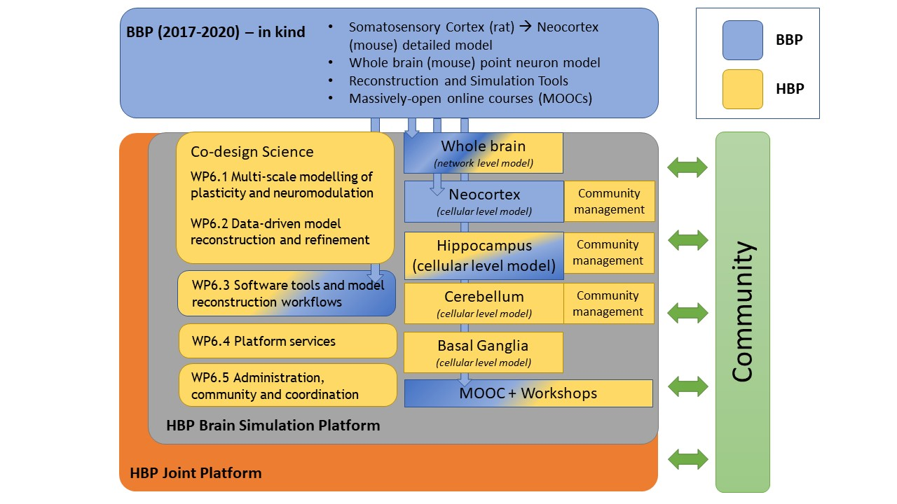

Figure 2: Caption for Figure 2.

Figure and Table additional information for Figure 2.

Landscape oriented page

Portrait oriented pages resume